**EXP NO: 12**

**Aim:** To Create a Virtual Machine with 1 CPU, 2GB RAM and 15GB storage disk using a Type 2 Virtualization Software.

**Implementation:**

1.install and setup VM ware software and create a new virtual machine

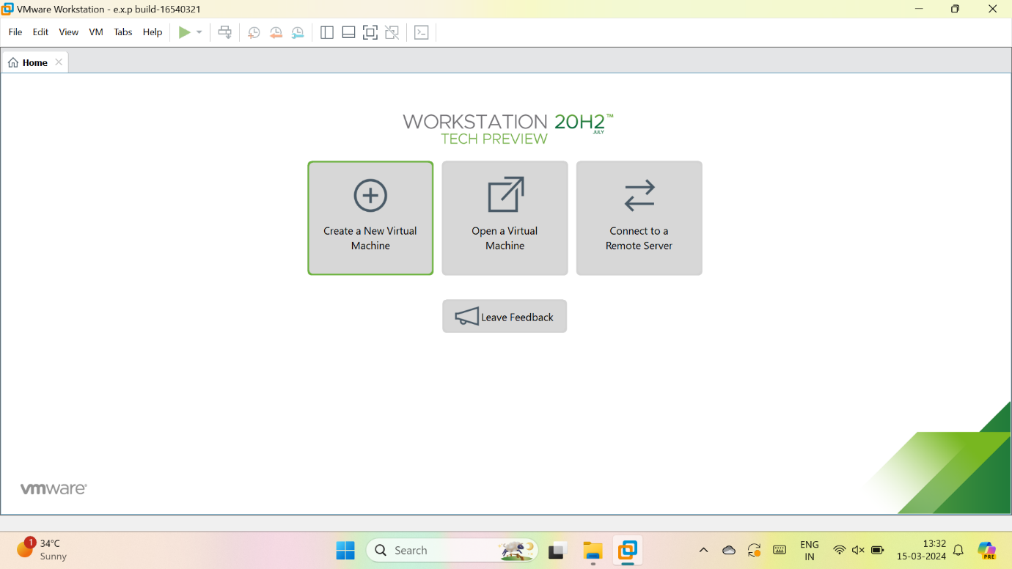

2.select typical

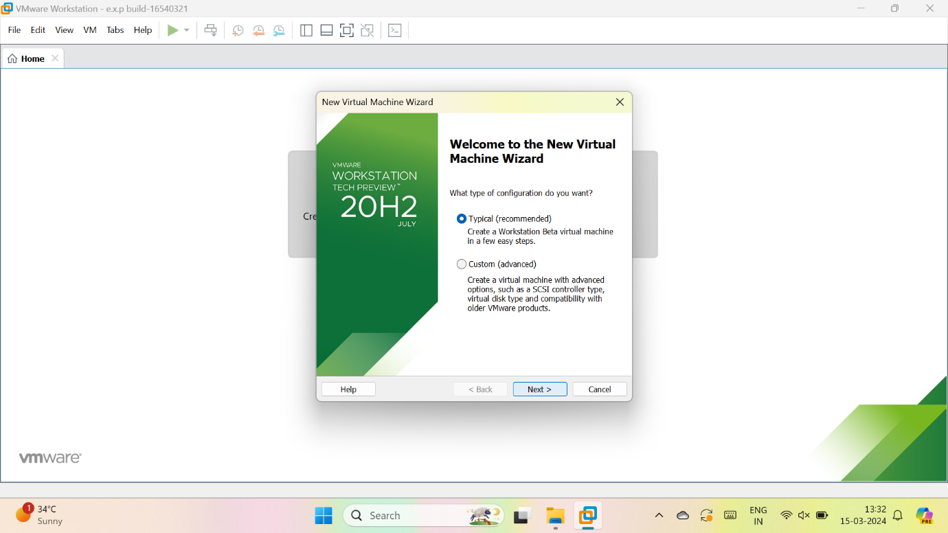

3.we have to select, I will install the OS later

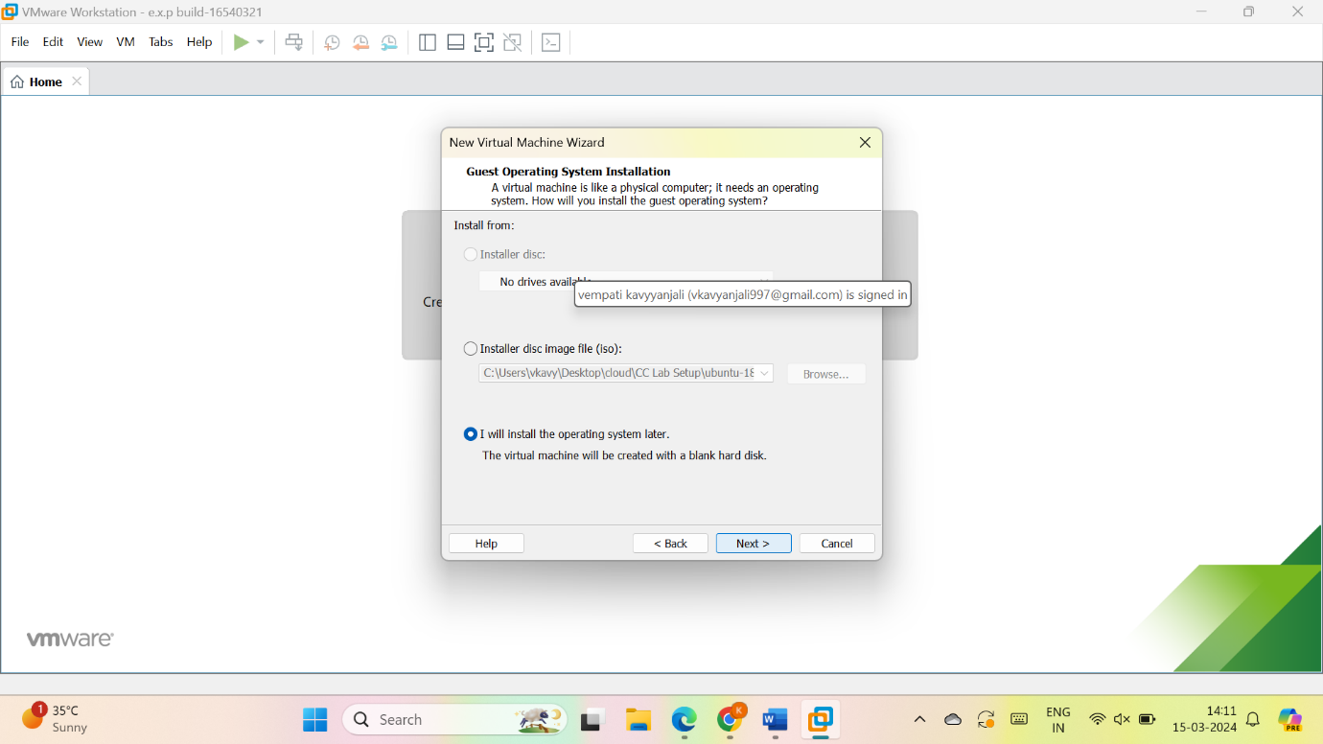

4.give name for VM

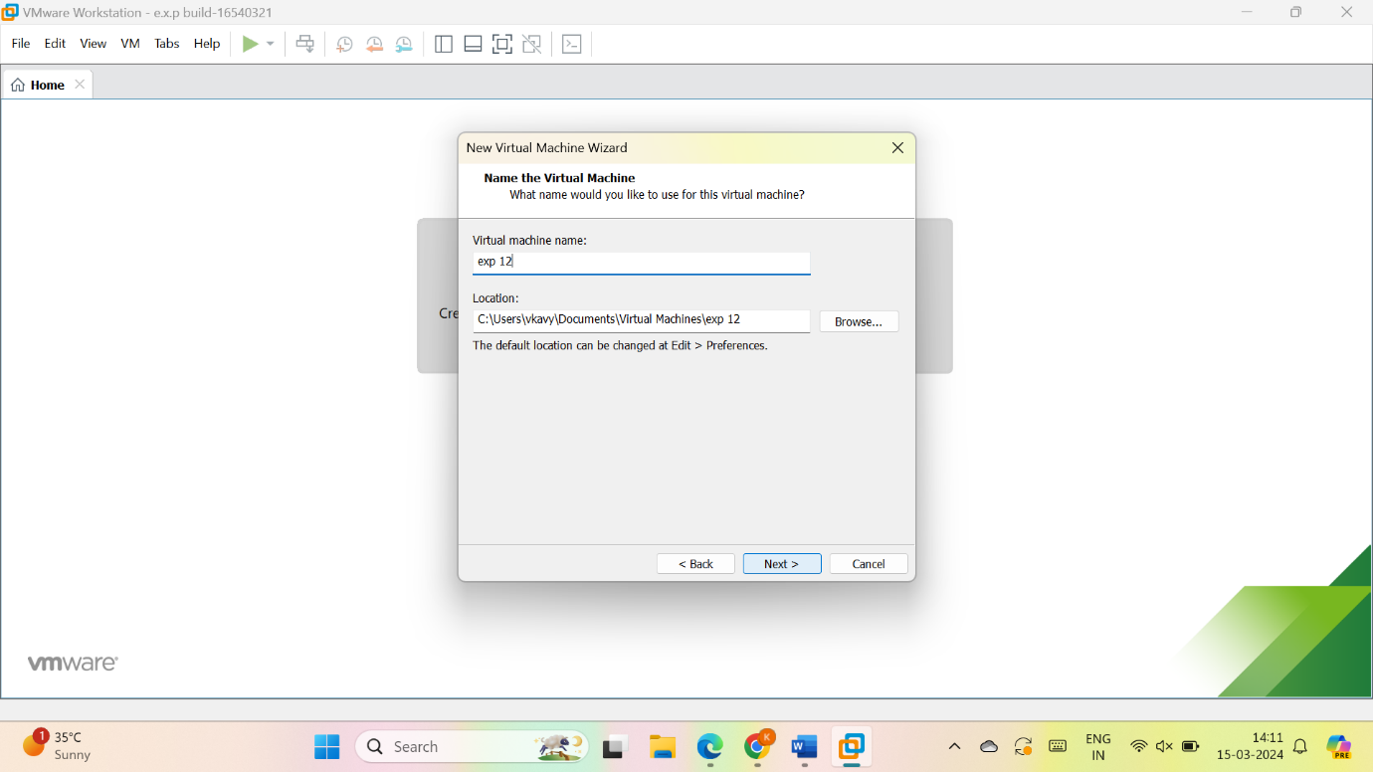

5.give the maximum size of disk as 15GB and select, store virtual disk as a single file and give next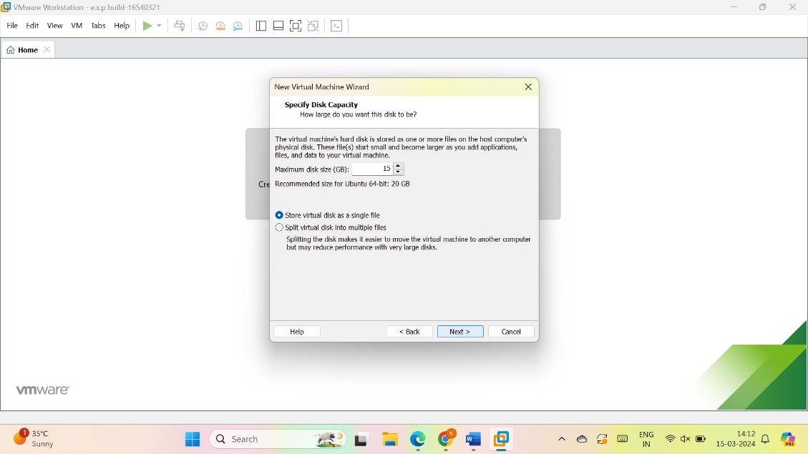

6.check the description

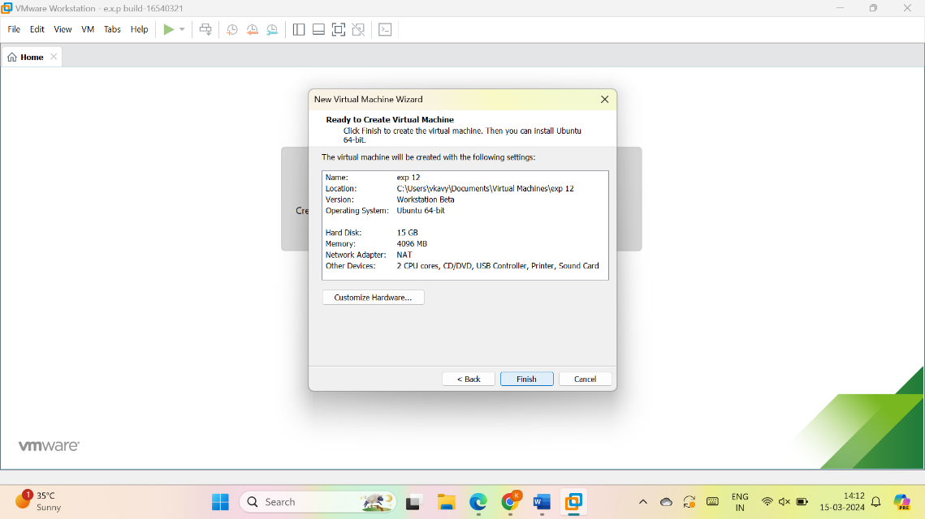

7.vm is created

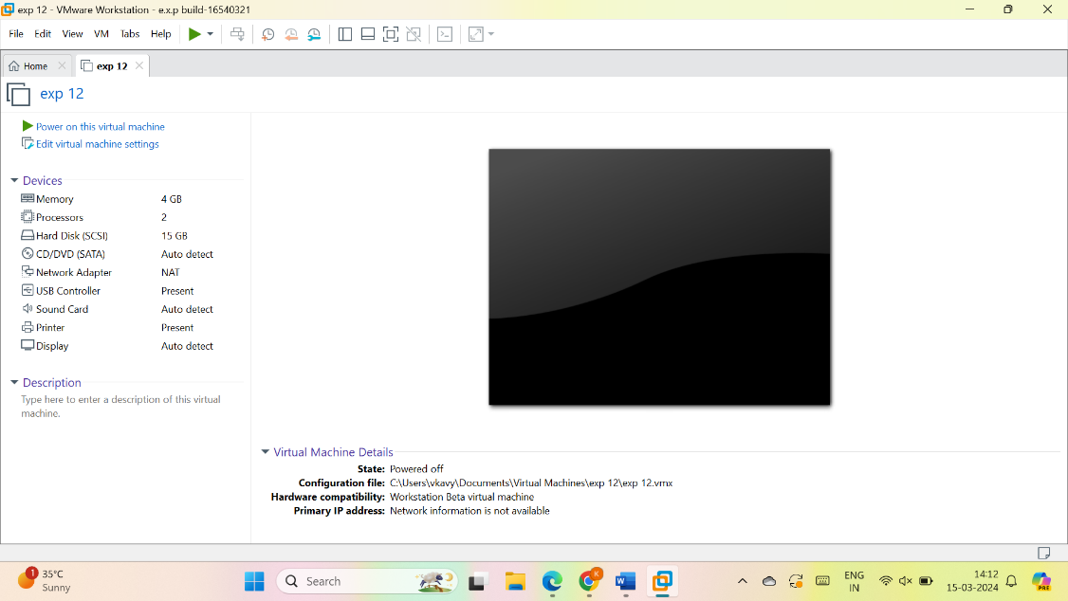

8. As per given question we have to modify the description of VM : 1 CPU, 2GB RAM and 15GB

Select memory and modify the 4GB into 2GB

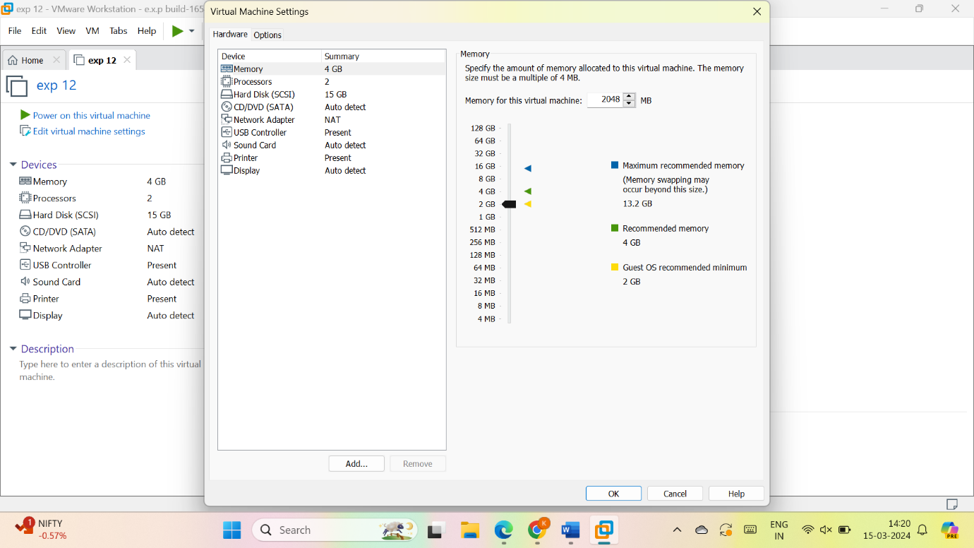

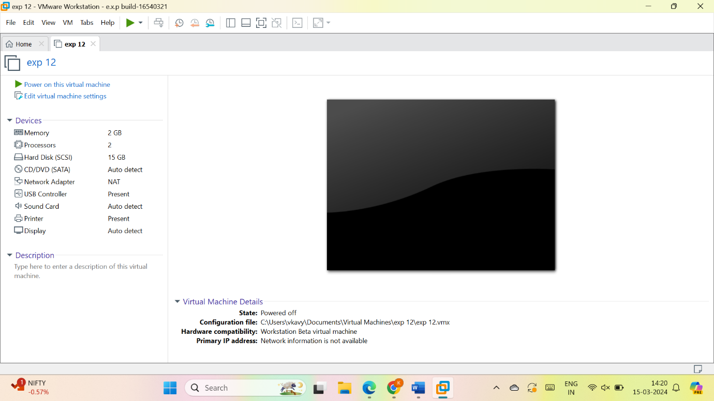

Select the processor and change no of processors from 2 to 1

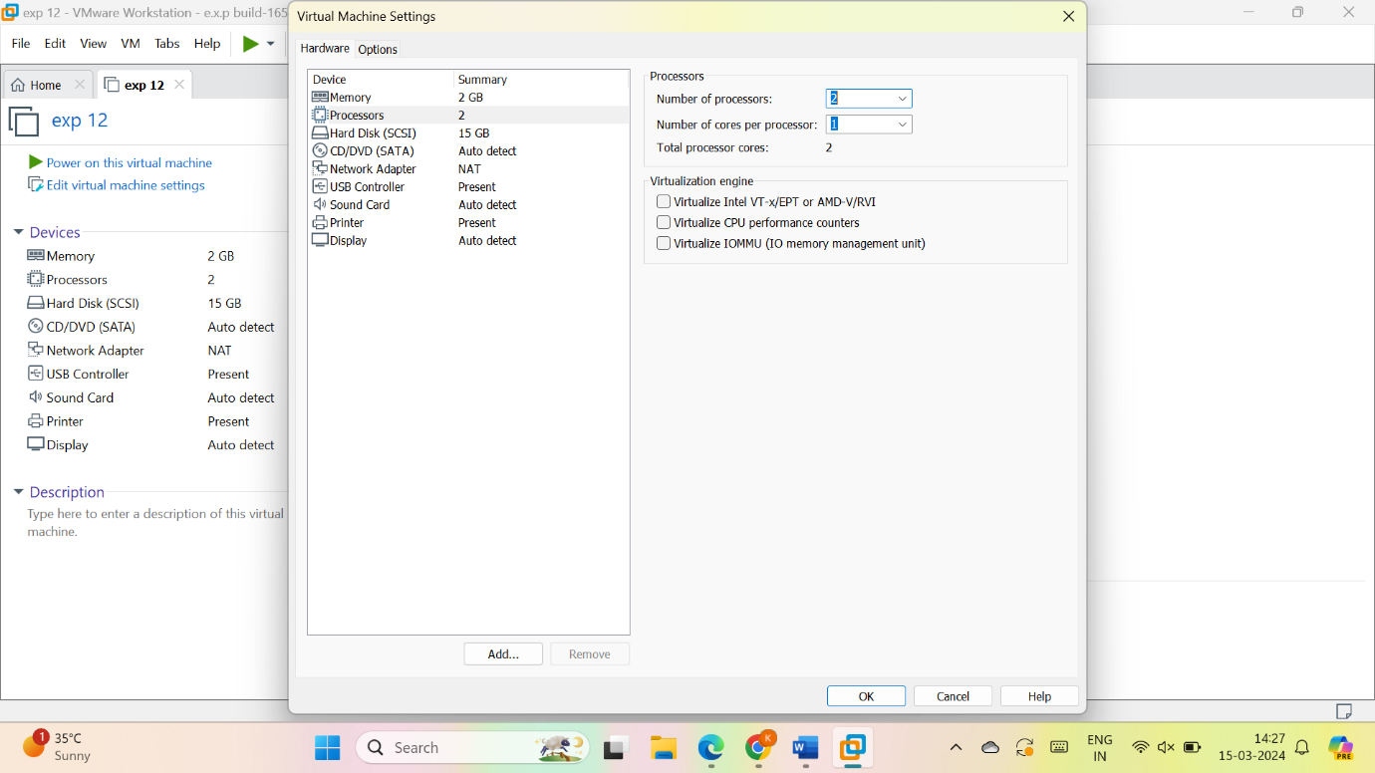

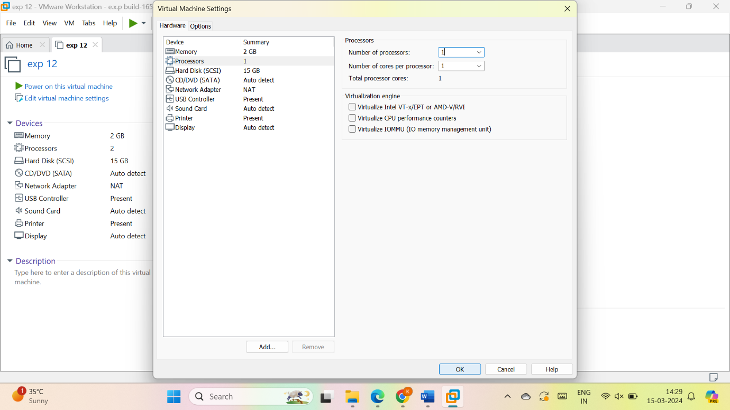

10.now the VM is created as per given data

